**Prolonged Heat Exposure in Florida's Construction Workforce: Investigating Cognitive** Fatigue, Emotional Resilience, Strained Family Relationships, and Adaptive **Coping Mechanisms to Understand the Broader Impacts of Heat on Holistic** Worker Well-Being and Family Dynamics

Principal Investigator (PI):

Candace Jungers

Graduate Student in the Master of Science in Engineering, Construction Management Program Florida Gulf Coast University (FGCU)

U.A. Whitaker College of Engineering Fort Myers, FL, USA

Email: [Cjungers7849@eagle.fgcu.edu](mailto:Cjungers7849@eagle.fgcu.edu) Phone: (832) 276-1231

Professor:

Ahmed S. E1sha11, Ph.D.

Assistant Professor

Department of Bioengineering, Civil Engineering, and Environmental Engineering Joint Appointment with The Water School

Florida Gulf Coast University (FGCU) Fort Myers, FL, USA

Email: [aelshall@fgcu.edu](mailto:aelshall@fgcu.edu) Phone: (239) 590-7591

Project Details:

Proposed Start Date: January 2025 Proposed End Date: May 2025

Budget: Self-funded as part of the academic requirements for the Master's in Engineering program in Construction.

Affiliation:

Florida Gulf Coast University 10501 FGCU Blvd South Fort Myers, FL 33965

Phone: (239) 590-1213

# Project Summary

Prolonged exposure to extreme heat is an urgent and escalating challenge in the construction industry, particularly in regions like the Southeastern United States and in places such as Florida, where high temperatures and high humidity are daily realities. While the physical effects of dehydration and heat exhaustion are well-documented, the psychological and social implications still need to be explored. This project investigates the broader impact of heat exposure on a worker's personal life and mental well-being. Impaired mental health can affect decision-making, relationships, and emotional stability, leading to cascading effects that extend beyond the job site and into the worker's homes, communities, and families. By broadening our exploration of these dynamics, we can foster a more sustainable, human-centered approach to safeguarding workers' health and safety.

This study investigates the relationship between extreme heat exposure and construction workers' mental and social well-being. Specifically, it seeks to answer the question: Does prolonged exposure to extreme heat create significant mental health and personal life challenges for construction workers in Florida? This exploration aims to assess how prolonged heat stress affects cognitive function, emotional regulation, and interpersonal relationships, both professionally and personally. Additionally, it examines how workers' strategies for coping with heat stress influence their family lives, whether by creating additional tension and conflict at home or fostering stronger family bonds and appreciation for recovery time.

The research employs a mixed-methods approach, using surveys to assess stress, irritability, and life satisfaction, along with interviews to explore personal experiences and coping mechanisms. Participants will maintain daily logs to provide additional insights into the relationship between workplace stressors and personal life outcomes. Supervisory staff will serve as a control group, enabling comparisons with workers directly exposed to heat.

Preliminary findings are expected to reveal that prolonged heat exposure contributes to mental fatigue, strained relationships with colleagues and loved ones and emotional withdrawal.

However, the study also anticipates that some workers may report positive adaptations, such as greater self-awareness of physical and mental limits or stronger family bonds due to shared coping mechanisms. The study will explore these dualities, highlighting the complexities of worker experiences under extreme conditions and offering potential avenues for positive change.

The outcomes of this research will provide critical insights into the intersection of workplace conditions and personal lives. By addressing the impacts of heat stress on personal well-being, this study underscores the importance of valuing workers not just as professionals but as individuals with multifaceted lives. In doing so, it contributes to creating safer, healthier, and more equitable working environments amid mounting climate challenges. Moreover, the findings of this research have the potential to inform and shape workplace policies, such as cooling strategies and mental health resources, thereby directly impacting the safety and well-being of construction workers.

# Introduction

The construction industry faces unique challenges due to rising global temperatures, particularly in regions like Florida, where extreme heat and humidity pose significant risks to worker health. Workers often perform physically demanding tasks outdoors, making them highly vulnerable to heat-related illnesses. Climate change has increased the frequency, intensity, and duration of heat waves, raising concerns for outdoor workers (Guirguis et a1., 2021). By 2050, Florida is projected to experience a 50% increase in the number of days with temperatures exceeding 90°F, further exacerbating occupational risks (U.S. Global Change Research Program, 2017).

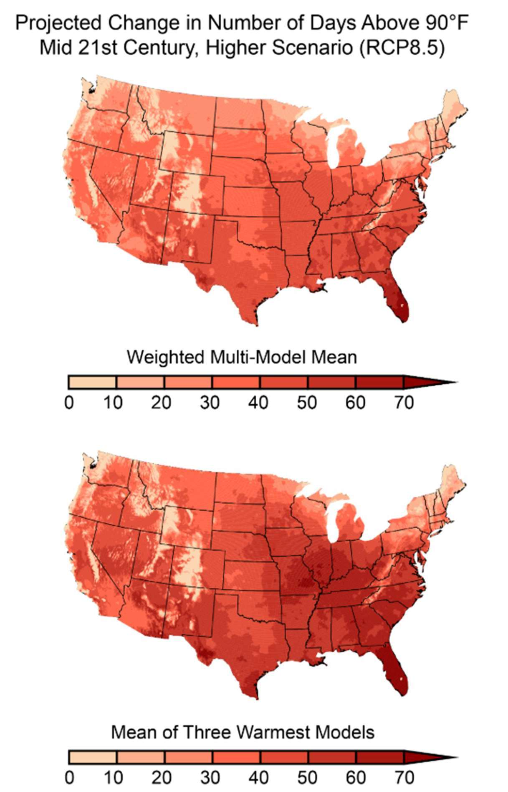

Figure 6.9 (U.S. Global Change Research Program, 2017) illustrates the projected increase in extreme heat days over the next several decades.

While the physical impacts of heat—such as dehydration, heat exhaustion, and heat stroke—are well-documented (Kjellstrom et a1., 2009; Maloney & Forbes, 2011), less attention has been given to the psychological and social dimensions. Rising temperatures not only strain the body but also affect mental well-being, increasing fatigue, anxiety, and stress among workers (Acharya et a1., 2018). For construction workers, these challenges are amplified by the physical demands of their jobs and the unpredictability of weather conditions.

Heat stress extends beyond the workplace, influencing mood, emotional stability, and personal relationships (Kotera et al., 2020). As climate change intensifies these stressors, its impacts ripple through workers' families and communities, revealing broader societal consequences of environmental heat exposure. Addressing these dynamics is critical, especially in high-risk regions like Florida, where the multifaceted challenges of extreme heat demand innovative and effective interventions.

Occupational health research has historically focused on generalized workplace stressors, such as excessive job demands and long working hours, with limited exploration of environmental factors like extreme heat. Studies in extreme environments, such as Antarctica, show that prolonged exposure to harsh conditions leads to cumulative stress, elevated cortisol levels, and mental fatigue (Alfano et al., 2021). These findings suggest that environmental stressors significantly impact mental health, but similar mechanisms in high-heat settings, particularly among construction workers, remain underexplored. Stress from work often carries over into personal life, a phenomenon known as the "spillover effect" (Kotera et al., 2020). This occurs when workplace stress negatively influences family life, leading to strained relationships and diminished well-being (Bolger et al., 1989). For example, Boschman et al. (2013) found that psychosocial stressors in construction frequently result in irritability, emotional withdrawal, and strained family dynamics. The spillover effect can also extend to environmental stressors like extreme heat, which amplify psychological strain. However, the interplay between heat stress, family dynamics, and interpersonal relationships remains under-researched, highlighting a critical gap in understanding occupational stress holistically.

Cognitive and emotional fatigue caused by heat exposure is particularly concerning. Workers in high-heat environments often experience reduced concentration, slower decision-making, and an increased risk of errors (Ramsey et a1., 1983; Spector et al., 2019). Emotional instability, such as irritability, anxiety, and frustration, frequently arises from prolonged heat exposure, potentially leading to workplace conflicts and difficulty managing stress (Maloney & Forbes, 2011).

Additionally, mood disturbances, including persistent sadness and feelings of helplessness, further impact workers' productivity and mental health (Acharya et al., 2018).

Heat-induced stress frequently affects workers' personal lives, diminishing their ability to engage with families and maintain healthy relationships. Studies like Kotera et a1. (2020) highlight the spillover effect, where workplace stress reduces emotional availability and quality time at home. However, few studies examine how heat stress specifically influences these dynamics,

underscoring the need for research on the broader impacts of heat exposure on workers' professional and personal lives.

# Research Objectives

This study examines the question: **Does prolonged exposure to** extreme heat create **significant** mental health **and personal** life **challenges for construction workers in Florida?** By focusing on the cognitive, emotional, and relational challenges posed by heat stress, this research seeks to uncover new insights into the broader consequences of heat exposure. Specifically, it aims to explore how heat-induced stress manifests in workers' professional and personal lives, identify the unique challenges faced by construction workers in high-heat regions, and provide a foundation for future studies and interventions aimed at improving worker well-being.

**Methodology Parameters**

Participants will be recruited from London Bay Homes construction sites in Cambridge Park and Mediterra in Naples, Florida. The study focuses on entry-level construction workers in physically demanding roles who are regularly exposed to extreme heat. These sites offer diverse working conditions, including both indoor and outdoor environments with varying sun exposure and airflow, providing a comprehensive understanding of heat exposure across multiple contexts.

The study will recruit **15—30 participants** from a range of physically intensive trades to ensure diverse representation of those most affected by heat. The targeted groups include:

* **Framers and Stucco Workers (ANF Stucco and Framing):** These trades typically work on incomplete structures with no climate control, facing prolonged exposure to direct sunlight and high temperatures.
* **Landscapers (Sunny** Grove): Their work involves intense physical activity in open outdoor spaces, heightening their vulnerability to heat-related fatigue and stress.
* **Mechanical Workers (AC Trim) and Electrical Workers (Alliance Electric):** These trades often perform physically demanding tasks in enclosed spaces with limited airflow, exacerbating heat exposure risks.

While this study seeks diversity in age, gender, and trade, the selection process will prioritize roles and responsibilities directly correlated with high heat exposure and physical exertion. This focus ensures that the study captures the most relevant data for understanding the impacts of heat stress on workers' mental well-being and personal lives. Senior employees, often in supervisory roles with reduced physical demands and greater access to rest periods, will serve as the control group for this study. This inclusion provides a basis for comparison, allowing the research to

focus on differences between workers experiencing high physical strain and heat exposure and those with less physically demanding roles.

Preliminary observations during site visits have already highlighted differences in heat exposure based on job roles. For instance, younger, entry-level workers often face greater physical strain due to their responsibilities, while senior employees engage in more cognitive tasks, such as coordination and oversight, with reduced time spent in high-exposure conditions. By focusing on entry-level and physically demanding positions, the study will provide targeted insights into how heat exposure affects those most vulnerable to its impacts.

This targeted recruitment strategy will ensure that the findings are both relevant and actionable while addressing potential variability in experiences due to job roles, responsibilities, and exposure levels.

# Data Management Plan

As a student new to the intricacies of data management, this study aims to implement a foundational strategy based on the FAIR principles (Findable, Accessible, Interoperable, and Reusable). While the research will strive to adhere to these principles, this project will also serve as an opportunity for me to learn and develop the necessary skills to effectively manage data in alignment with these standards. The approach will be a combination of applying basic FAIR practices and actively acquiring knowledge of advanced data management techniques.

To make the data **Findable,** I will begin by assigning simple, unique identifiers to each dataset, such as participant IDs for anonymization. I plan to explore tools like Zenodo or Figshare to understand how DOIs (Digital Object Identifiers) are assigned to datasets, enabling global discoverability. Metadata will be created to provide basic information about the data, such as variable definitions, collection methods, and file formats. As I progress, I will study metadata standards like Dublin Core and learn how to enhance metadata to make datasets more searchable and understandable.

For **Accessibility,** I will store data in secure and easily manageable formats, such as Excel for quantitative data and Word documents for qualitative data, while ensuring files are password- protected. To learn about trustworthy repositories, I will explore FGCU's Institutional Repository and platforms like Google Drive. I will also familiarize myself with standardized access protocols like HTTPS to ensure data can be safely shared. As this is a learning process, I will consult with faculty and use online resources to understand how to balance data accessibility with participant privacy.

To make the data **Interoperable,** I will save datasets in widely recognized formats, such as CSV for numerical data and TXT for interview transcripts, which are simple yet compatible with most tools. I will focus on learning how to use controlled vocabularies and community standards to ensure data consistency. For instance, I will study CF Metadata Standards and explore platforms

like GitHub for understanding version control and repository integration. This will be a learning curve, and I will leverage tutorials and resources to deepen my understanding of interoperability.

Ensuring **Reusability** will involve providing clear documentation for datasets, even at a basic level. I will create notes on data collection methods and any transformations applied to make the datasets understandable to others. While I may not immediately implement advanced licensing systems like Creative Commons, I will begin by clearly stating usage rights in accompanying documentation. As I gain experience, I will explore how to apply for appropriate licenses and learn about version control systems like Git to ensure transparency in data handling.

This project will also follow ethical guidelines to protect participants' privacy. I will anonymize data by assigning participant IDs and consulting FGCU's Institutional Review Board (IRB) to ensure compliance with ethical standards. Over winter break, I plan to start the process of obtaining IRB certification to enhance my understanding of ethical research practices and ensure proper adherence to protocols. In cases where data sharing is required, I will start with metadata and limited datasets to uphold ethical practices (FGCU IRB, 2020).

As someone new to this field, I acknowledge my limitations in fully implementing advanced FAIR principles. However, this study will serve as an opportunity to learn through hands-on experience, consultations with faculty, and the use of resources like FAIR tutorials and data management workshops. While the initial implementation may be basic, I aim to progressively enhance my understanding and practices to align with FAIR standards over time. This approach ensures that my data management practices are not only effective for this project but also set a strong foundation for future research endeavors.

# Recruitment and Orientation (Weeks 1—2)

During the initial phase of the study, I will seek permission from the owners and leadership at London Bay to conduct research at their construction sites. A formal proposal will be presented, outlining the purpose of the study, its academic focus, and the potential value of the findings.

This includes emphasizing that the research is part of a graduate-level academic project exploring an under-researched area: the impact of extreme heat exposure on workers' personal and family lives. By highlighting the unique and innovative nature of the study, the aim is to build trust and secure the company's support.

Once permission is granted, recruitment efforts will begin at the approved sites. Informational materials such as flyers and email announcements will be distributed to inform potential participants about the study's purpose, scope, and expectations. Prospective participants will be reassured that the research focuses on their personal experiences and is not intended for any evaluative or performance-related purposes. Participation will be entirely voluntary, and participants will retain the right to withdraw at any time without any consequences.

To encourage participation and demonstrate appreciation, I will provide a catered lunch at the project sites for participants as a gesture of gratitude. Additionally, I plan to organize a job site

pizza party to create a casual and inclusive environment, fostering camaraderie among the team while expressing my appreciation for their efforts. During this phase, I will engage with potential participants directly, explaining the importance of their contributions and asking for their support in gathering insights on a topic that has received limited attention in academic research.

Emphasis will be placed on the value of their experiences in contributing to a broader understanding of how heat stress impacts personal well-being.

Participants who express interest will be provided with detailed information about the study's expectations and procedures, including the use of surveys, daily logs, and interviews. Clear, concise informed consent forms will be distributed and reviewed, ensuring that all participants fully understand the nature of the research and their rights (FGCU IRB, 2020).

# Data Collection (Weeks 3-10)

Data collection for this study will employ a combination of bi-weekly surveys, daily logs, and semi-structured interviews to gather both quantitative and qualitative data. These methods have been carefully chosen and designed to ensure they align with the study's objectives, minimize participant burden, and provide a comprehensive understanding of how extreme heat exposure impacts construction workers' mental well-being and personal lives.

Surveys will be administered every two weeks to collect participants' insights on stress, fatigue, and mood fluctuations over time. The surveys will use the Perceived Stress Scale (PSS), a validated psychological tool specifically chosen for its ability to measure perceived stress levels based on key factors such as unpredictability, overload, and controllability in participants' lives (Ray, 2024). This scale is particularly suitable for this study as it facilitates comparisons across individuals and time periods, making it ideal for identifying changes in stress levels caused by prolonged heat exposure. The survey will include a mix of closed-ended questions to provide quantitative data and open-ended prompts to capture richer, qualitative insights. Example questions include: “Rate your overall stress level this week on a scale of 0 to 4,” “How often did heat affect your ability to engage with family or friends this week?” and “Describe one way that heat influenced your mood or energy level during work this week.” The surveys will be distributed digitally via Google Forms, enabling participants to access and complete them conveniently using their smartphones or other devices. Feedback gathered during a pilot testing phase in the recruitment stage will be used to refine the survey questions, ensuring clarity relevance, and ease of completion for all participants.

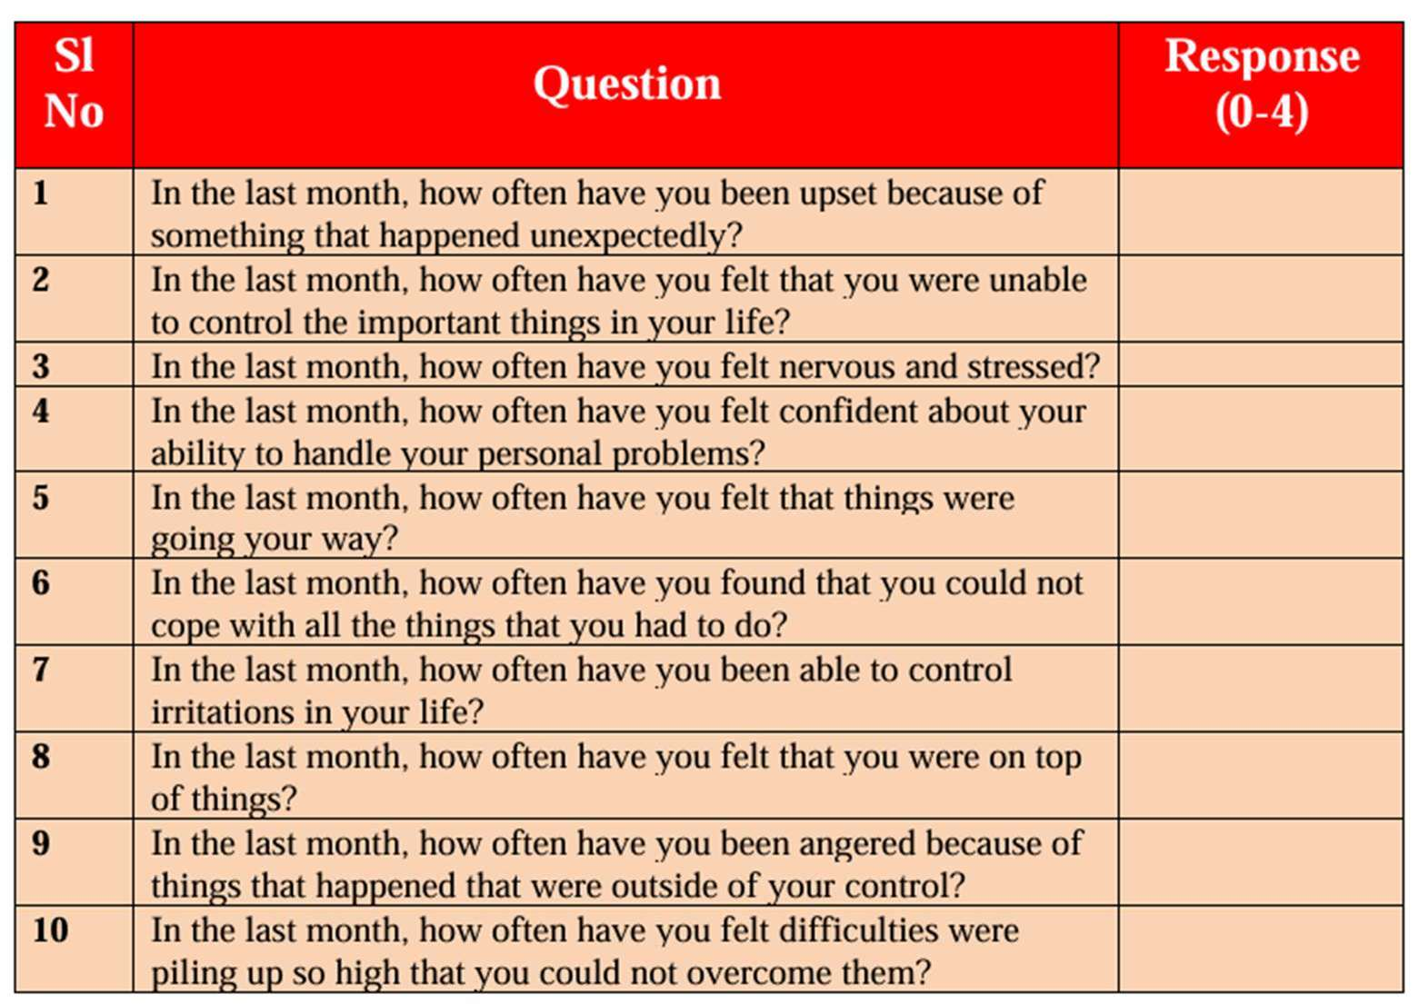

Figure 1 (Ray, 2024) illustrates the PSS Assessment Table, which is designed to capture various aspects of perceived stress.

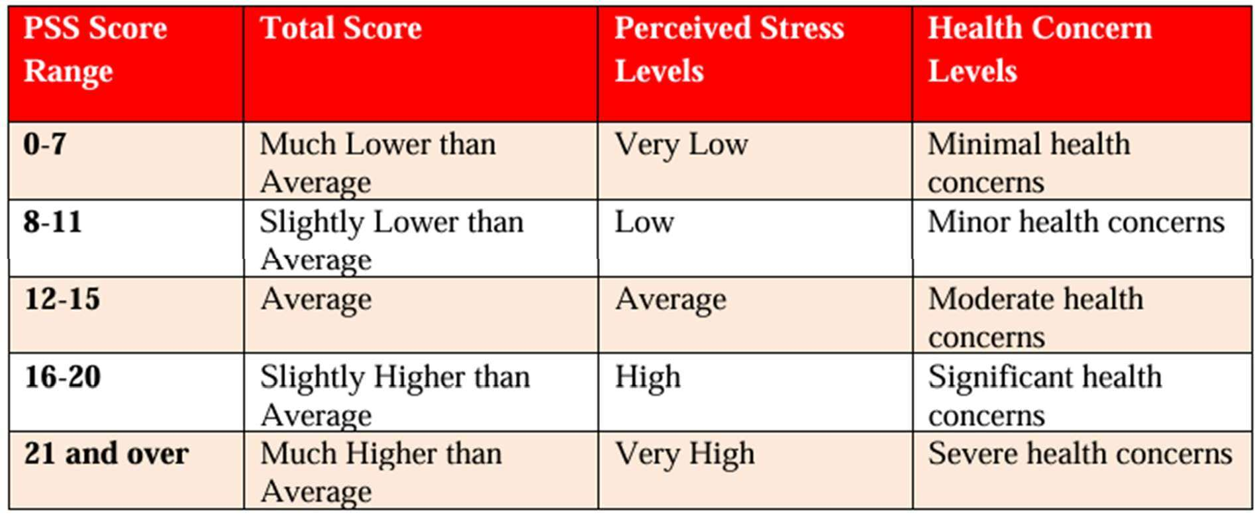

Figure 2 (Ray, 2024) demonstrates the scoring process for the Perceived Stress Scale, outlining key assessment criteria.

Daily logs will provide a more frequent, in-depth account of heat exposure and its effects on participants' day-to-day experiences. To balance the need for contextual and personal data with the burden on participants, two types of daily logs will be used. First, site superintendents who are not part of the study will maintain objective logs to document contextual details, including

weather conditions, general workload, and site-level challenges. These logs will provide essential baseline information against which participant data can be analyzed (Boschman et a1., 2013).

Second, participants will be encouraged to complete their own logs twice a week to share personal reflections on how heat affects their stress levels, mood, and interpersonal interactions. The participant logs will be designed to take no more than five minutes to complete, with prompts such as: “What challenges did you face due to heat exposure today?” and “How did these challenges affect your mood or interactions with others?” To further encourage participation and maintain engagement, participants who consistently complete their logs throughout the study will be eligible for a gift card drawing as an incentive. This approach balances the importance of collecting meaningful personal data with the practical realities of participants' demanding work schedules.

Semi-structured interviews will provide an opportunity to delve deeper into the emotional and relational impacts of heat exposure, offering qualitative insights that surveys and logs may not fully capture. Interviews will be scheduled at times that are convenient for participants, such as during their scheduled breaks or at the end of the workday, to avoid interfering with their job responsibilities. Each interview will last approximately 15 minutes to respect participants' time and work commitments. The interviews will be guided by open-ended questions designed to explore how heat stress affects participants' energy levels, mood, and personal relationships.

Examples of questions include: “How has heat stress affected your energy levels and mood outside of work?” and “Can you describe any changes in your relationships with family or friends due to workplace heat exposure?” Additionally, participants will be asked for feedback on their experience participating in the study, ensuring that their perspectives inform the research process. Interview responses will be recorded in a personal journal, and participants will be given the opportunity to review and approve the notes before they are finalized. If a participant

requests that specific information be excluded, it will be immediately removed without question. This practice ensures participants feel fully in control of their contributions and fosters a sense of trust and respect throughout the study (Kotera et al., 2020).

Together, these data collection methods are designed to provide a rich and nuanced understanding of the effects of extreme heat exposure on construction workers. By combining quantitative surveys, reflective logs, and in-depth interviews, the study captures both measurable patterns and personal narratives, ensuring a comprehensive exploration of the research question. Every effort will be made to streamline these processes and accommodate participants' demanding schedules, reflecting the study's commitment to ethical and participant-centered research practices.

# Data Analysis (Weeks 11-13)

To analyze the data collected, a combination of straightforward statistical tools and manual thematic methods will be used, reflecting my current skill level and ensuring the process remains

accessible and replicable. This section explains how survey responses, daily logs, and interview notes will be analyzed to extract meaningful insights about the impacts of extreme heat exposure.

# Quantitative Analysis

Survey and log data will be organized and analyzed using Microsoft Excel, a user-friendly platform well-suited for managing structured data. Survey responses will first be transferred from Google Forms into Excel, where each participant will be assigned a unique ID to ensure anonymity. Responses will be categorized by week and question type, enabling me to track trends over time. For instance, I will group stress scores reported weekly to identify any noticeable patterns in participants' experiences (Boschman et a1., 2013).

Descriptive statistics will be used to summarize the data, including calculations for averages (mean), medians, and ranges for stress and fatigue scores. For example, the average stress score for all participants in a given week will be calculated to observe fluctuations across the study period. Excel's built-in functions, such as AVERAGE and STDEV, will simplify this process, ensuring accurate and efficient calculations.

To explore relationships between variables, such as heat exposure and reported stress levels, I will use basic correlation analysis. For example, I will assess whether higher reported exposure to extreme heat corresponds to increased fatigue scores. Excel's CORREL function will be used for these analyses. Since I lack formal training in advanced statistical methods, I will consult online tutorials and resources, including instructional videos on platforms like YouTube, to learn how to use these tools effectively. If additional guidance is needed, I will seek support from professors or tutors to ensure the analysis is conducted rigorously and accurately.

# Qualitative Analysis

Open-ended survey responses and interview notes will be analyzed manually using thematic coding to uncover recurring patterns and insights. This approach aligns with Boschman et al. (2013), who highlighted the value of qualitative methods in exploring psychosocial stressors in construction workers. This process will begin with a thorough review of all transcripts and written responses, during which I will identify common keywords and phrases, such as “fatigue,” “relationship strain,” or “coping strategies.” These keywords will serve as initial codes, which I will then group into broader themes. For instance, mentions of “low energy” and “difficulty focusing” may combine under a theme like “emotional exhaustion.”

The coding process will be documented in an organized spreadsheet, where each participant's responses will be linked to their assigned codes. This manual approach ensures that I fully engage with the data, allowing me to capture subtle nuances that might be overlooked by automated software. I will regularly review and refine the themes to ensure they accurately reflect participants' experiences.

The coding process will be documented in an organized spreadsheet, where each participant's responses will be linked to their assigned codes. This manual approach ensures that I fully engage with the data, allowing me to capture subtle nuances that might be overlooked by automated software. I will regularly review and refine the themes to ensure they accurately reflect participants' experiences.

Additionally, I will review resources from FGCU's library and other academic guides on qualitative research methods. I will practice coding on sample data to build my confidence and refine my approach. If available, I will also seek feedback from professors or peers to validate my thematic framework and coding process (Kotera et al., 2020).

In order to prepare for this analysis, I watched a video on cognitive biases prior to this report, which provided valuable insights into how subconscious biases could influence data interpretation. The video helped me recognize the importance of remaining impartial while analyzing participant responses and structuring themes. It also emphasized techniques to mitigate potential biases, such as actively questioning assumptions, seeking alternative explanations, and periodically reflecting on how personal perspectives might shape interpretations.

# Findings (Week 14)

After completing the quantitative and qualitative analyses, the findings will be integrated to provide a comprehensive understanding of the participants' experiences. For instance, quantitative trends in stress scores will be compared with qualitative insights from interviews to explore how reported stress aligns with personal accounts of heat exposure's impact on relationships and well-being. If discrepancies arise, I will revisit the raw data to refine the interpretation and ensure the findings are well-supported.

Visual summaries, such as charts or graphs, will be created in Excel to highlight key trends, making the data more accessible and easier to interpret. For example, I may create a line graph showing changes in average stress levels over the study period or a bar chart comparing fatigue scores across different trades. These visuals will be used to triangulate findings and ensure consistency between data sources (Acharya et a1., 2018).

By documenting every step of the analysis process, I aim to make this methodology transparent and repeatable for other researchers or students. The challenges I encounter and the strategies I use to overcome them, such as self-training in statistical techniques, will also be detailed. This documentation will not only enhance the rigor of this study but also provide a valuable resource for those conducting similar research in the future.

**Research Timeline**

**Mobilization**

Submit proposal to FGCU's IRB Receive official IRB approval

**Recruitment and Orientation**

**Research Activities Schedule: Examining Heat Exposure Effects**

Project Start



Permission & SiteSelection

Recruitment Consent Forms

Pilot Testing 1-2 ppl (not participants)

**Data Collection**

Distribute bi-weekly surveys (Monday's)

TASKS

Monitor survey submissions

Send personal log reminders (Sunday's) Collect personal and company logs

**Data Analysis**

Sort responses by question and participant Skill development and tutorials

Transfer data into the appropriate software Use software to quantify patterns

**Finn**s

Explore logs against identified themes Revisit data to refine interpretations

Create visual summaries of the data collected Write a detailed summary of key findings Document and incorporate participant feedback

Project Complete

WK 0 WK 1 WK 2 WK 3 WK 4 WK 5 WK 6 WK 7 WK 8 WK 9 WK 10 WK 11 WK 12 WK 13 WK 14

TIMELINE

# Research Timeline

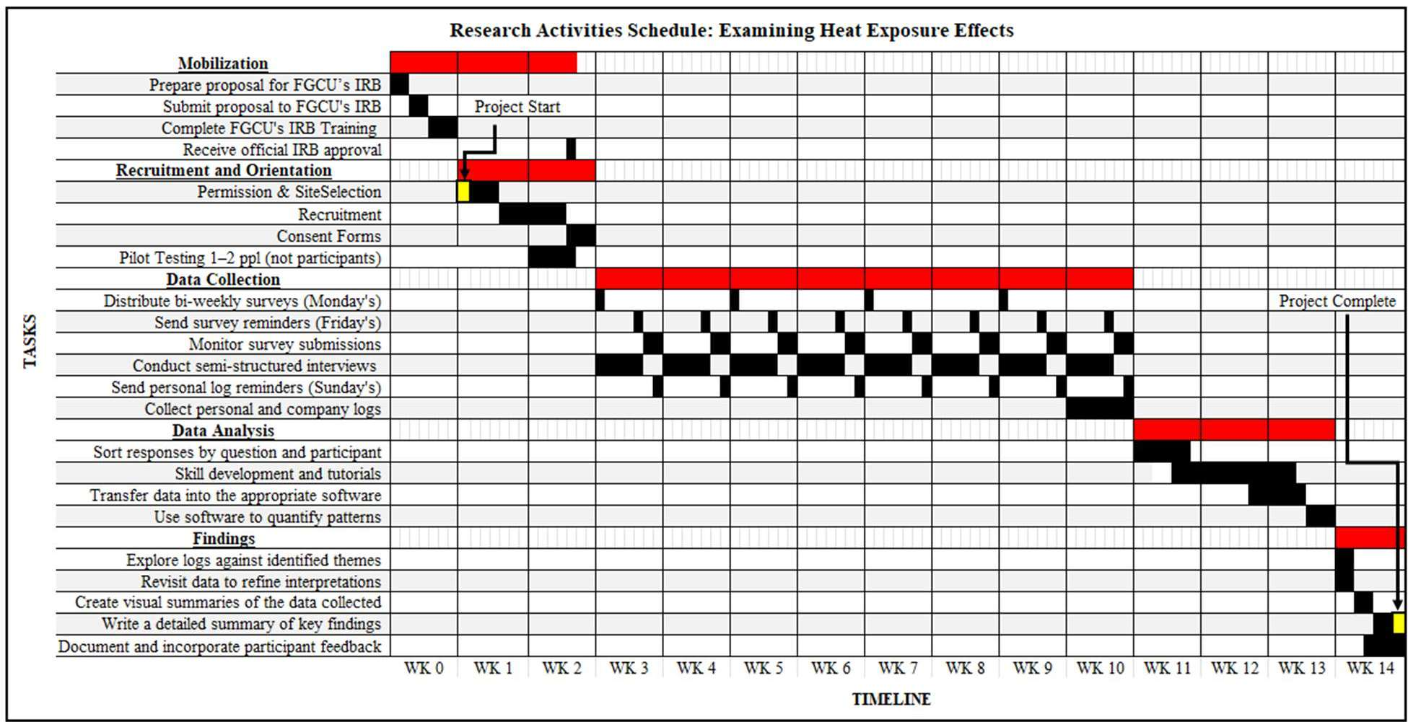

Figure A

# Contingency Plan

Two areas I anticipate being the most challenging in my research are data analysis and participant engagement. To address challenges in data analysis, I will allocate time for tutorials on software like NVivo or SPSS, practice with sample datasets, and seek feedback from professors or peers to ensure accuracy. Sharing preliminary findings for validation and refining interpretations based on feedback will further help mitigate errors.

For participant engagement, I will use incentives such as gift cards or catered lunches to maintain motivation. Clear communication, flexibility in deadlines, and regular updates on the study's progress will reinforce their commitment. To address potential dropouts, I will recruit a slightly larger participant pool and monitor engagement regularly, making adjustments as needed.

These areas represent the most challenging parts of my research, but weekly check-ins and mentorship support will help address issues promptly, ensuring the project stays on track and produces meaningful results.

# Ethical Considerations

This study places the highest priority on ensuring participants' rights, safety, and privacy while maintaining compliance with ethical research standards. Approval from Florida Gulf Coast University's Institutional Review Board (IRB) will be sought to ensure the research adheres to ethical guidelines and regulatory standards. The design and implementation of this study reflect a

commitment to transparency, confidentiality, and fairness, with particular attention given to mitigating potential biases (FGCU IRB, 2020).

Participants will be fully informed about the purpose, scope, and procedures of the study. Informed consent forms will clearly outline their rights, including the ability to withdraw from the study at any point without penalty. To ensure voluntary participation and to mitigate the potential influence of workplace hierarchies, recruitment will be conducted independently by the researcher, with no involvement from supervisors or management. Direct communication with participants will clarify that the research is solely for academic purposes, independent of company evaluations or performance assessments. The exclusion of third parties in recruitment, data collection, and analysis will safeguard participants' autonomy and protect them from perceived obligations.

Confidentiality will be maintained throughout the study by anonymizing all data. Unique participant codes will be assigned, ensuring no identifying information is included in the analysis. All data will be securely stored on encrypted platforms, accessible only to the researcher. Raw data will not be shared with third parties, and any identifiable information disclosed during interviews or logs will only be included in reports with explicit participant consent. Findings will be presented in aggregate form, preserving anonymity and protecting individual identities.

The role of superintendents will be limited to maintaining their usual daily logs, which document contextual details such as weather and site conditions. These logs will provide supplementary data to contextualize participant responses. Superintendents will not participate in the study or have access to any participant-specific data, ensuring ethical boundaries are maintained. This separation reinforces the confidentiality of participants while providing additional insights for analysis.

To minimize the burden on participants, surveys will take no more than 10 minutes to complete, and participants will only be asked to maintain daily logs twice weekly. Interviews will be brief, lasting approximately 15 minutes, and scheduled during breaks or other convenient times to avoid interfering with work responsibilities. To encourage participation and show appreciation, incentives such as a catered lunch and eligibility for a gift card drawing will be offered.

The study acknowledges that discussing topics such as stress and personal relationships may cause discomfort for some participants. To address this, participants will have the option to skip any survey or interview questions they find sensitive. Local mental health resources will be made available to provide additional support. During interviews, a trauma-informed approach will be used, ensuring participants feel respected and comfortable.

A significant focus of this study is addressing and avoiding biases in data collection and interpretation. To prevent personal expectations from influencing the results, the researcher will adhere strictly to the data and refrain from interpreting it to align with anticipated outcomes.

Survey questions, log prompts, and interview scripts will use neutral language to ensure responses reflect participants' authentic experiences rather than being guided by the researcher's assumptions. The researcher will adopt a structured, systematic approach to data analysis, ensuring objectivity by coding qualitative data consistently and corroborating findings across multiple data sources. By documenting all steps of the analysis process and seeking feedback from academic mentors or peers, the researcher will ensure that conclusions are based solely on the evidence collected.

Diversity and inclusion will also play a central role in participant selection, with efforts made to recruit individuals from a variety of trades, genders, and age groups. However, the study will focus primarily on entry-level positions to capture the experiences of workers with the highest physical exposure to heat. This approach ensures alignment with the study's objective of understanding the impacts of heat stress on physically demanding roles, rather than supervisory positions, which may involve different stressors unrelated to environmental conditions.

By integrating these ethical safeguards and methodological strategies, this study aims to uphold research integrity while providing a safe and respectful environment for participants. These measures ensure that the findings are robust, credible, and reflective of the true experiences of construction workers facing extreme heat exposure.

# Expected Results

This study is expected to reveal the complex effects of prolonged heat exposure on construction workers' mental well-being and personal lives, grounded in existing occupational health literature and enriched by this academic inquiry's unique perspective. Anticipated findings include a correlation between heat stress and mental fatigue, emotional instability, and interpersonal challenges. Workers may report heightened irritability, strained relationships with family and coworkers, and reduced emotional availability. Additionally, findings are expected to show that high heat exposure exacerbates emotional stress during peak seasons, potentially leading to decreased productivity and increased turnover in the industry. However, it is also anticipated that some participants will identify adaptive strategies, such as developing greater self-awareness of their physical and emotional limits or fostering stronger family bonds through shared coping mechanisms. By exploring these dualities, the study aims to contribute original insights to the underexplored psychological and relational dimensions of occupational heat exposure (Greiner et al., 2022).

Preliminary findings, while not yet available, are informed by pilot studies and existing research, suggesting that heat-related stress disproportionately impacts younger, less experienced workers. The study methodology—rooted in validated tools such as the Perceived Stress Scale and thematic coding—ensures that findings will be both rigorous and actionable (Ray, 2024).

Deliverables will include a detailed academic report summarizing key findings and practical interventions. Anticipated interventions may include cooling strategies like portable shade structures, staggered work schedules, and organizational policies prioritizing mental health.

Resources for mitigating workplace stress spillover into home life, such as family support programs or counseling services, will also be outlined. These deliverables are designed to bridge academic discourse and practical application, offering insights to guide future interdisciplinary research into environmental stressors and their broader implications (Acharya et a1., 2018).

Expected outcomes are multifaceted. Academically, the study aims to fill a critical gap by examining the psychological and relational impacts of heat stress, providing a foundation for further work in environmental health, occupational psychology, and family dynamics.

Professionally, the findings are expected to serve as a case study for understanding how climate- related stressors affect personal and professional spheres, offering valuable insights for high-risk industries like construction, agriculture, and logistics. Long-term impacts may include improved industry practices, policy recommendations for heat mitigation, and broader recognition of mental health as a core component of occupational safety. This work aligns with the growing literature on occupational stress and seeks to provide actionable insights for policymakers and industry leaders (Kotera et a1., 2020).

Given the study's structured methodology, including a well-defined recruitment plan and flexible data collection techniques, the proposed outcomes are realistic and achievable within the project's scope and timeline. Anticipated challenges, such as variability in participant engagement or incomplete data, will be addressed through multiple data sources—surveys, logs, and interviews—and incentives to maintain participant motivation. By proactively addressing these potential obstacles, the research will uphold academic integrity while making meaningful contributions to understanding and mitigating the impacts of extreme heat on construction workers (Acharya et al., 2018). This work is expected to yield actionable insights that not only enhance the academic understanding of heat stress but also provide tangible recommendations to improve workers' quality of life and industry practices.

References

Acharya, P., Boggess, B., & Zhang, K. (2018). Assessing Heat Stress and Health among Construction Workers in a Changing Climate: A Review. *International Journal ofEnvironmental Research and Public Health, 15(2),* 247. https://doi.org/10.3390/ijerphl5020247

Alfano, C. A., Bower, J. L., Connaboy, C., Agha, N. H., Baker, F. L., Smith, K. A., et al. (2021). Mental health, physical symptoms and biomarkers of stress during prolonged exposure to Antarctica's extreme environment. *Acta Astronautica, 181,* 405W13. https://doi.org/10.1016/j.actaastro.2021.01.051

Boschman, J. S., van der Molen, H. F., Sluiter, J. K., & Frings-Dresen, M. H. W. (2013). Psychosocial work environment and mental health among construction workers. *Applied Ergonomics, 44(5),* 748-755. https://doi.org/10.1016/j.apergo.2013.01.004

De Sario, M., de’Donato, F. K., Bonafede, M., Marinaccio, A., Levi, M., Ariani, F., et a1. (2023). Occupational heat stress, heat-related effects and the related social and economic loss: a scoping literature review. *Frontiers in Public Health, 11.* https://doi.org/10.3389/fpubh.2023.1173553

Greiner, B. A., Leduc, C., O'Brien, C., Cresswell-Smith, J., Rugulies, R., Wahlbeck, K., et a1. (2022). The effectiveness of organisational-level workplace mental health interventions on mental health and wellbeing in construction workers: A systematic review and recommended research agenda. *PLOS ONE,* 17(11), e0277114. https://doi.org/10.1371/journal.pone.0277114

Kotera, Y., Green, P., & Sheffield, D. (2020). Work-life balance of UK construction workers: relationship with mental health. *Construction Management and Economics, 38{3),* 291-303. https://doi.org/10.1080/01446193.2019.1625417

Maloney, S. K., & Forbes, C. F. (2011). What effect will a few degrees of climate change have on human heat balance? Implications for human activity. *International Journal ofBiometeorology, 55{2),* 147-160. https://doi.org/10.1007/s00484-010-0320-6

Palinkas, L. A., & Wong, M. (2020). Global climate change and mental health. *Current Opinion in Psychology, 32,* 12-16. https://doi.org/10.1016/j.copsyc.2019.06.023

Ramsey, J. D., Burford, C. L., Beshir, M. Y., & Jensen, R. C. (1983). Effects of workplace thermal conditions on safe work behavior. *Journal ofsafety Research, 14{3),* 105-114. https://doi.org/10.1016/0022-4375(83)90021-X

Spector, J. T., Masuda, Y. J., Wolff, N. H., Calkins, M., & Seixas, N. (2019). Heat Exposure and Occupational Injuries: Review of the Literature and Implications. *Current Environmental Health Reports,* 6(4), 286-296. https://doi.org/10.1007/s40572-019-00250-8

U.S. Global Change Research Program (USGCRP). (2017). Chapter 6: Temperature changes in the United States. *In Climate science special report. Fourth national climate assessment, Volume I(pp.* 185-206). https://science2017.g1oba1change.gov/chapter/6/

Guirguis, K., Gershunov, A., Schwartz, R. E., Bennett, K., & White, J. (2021). Climate change and the increasing exposure of Californians to extreme heat. *npj Climate and Atmospheric Science, 4,* 29. https://doi.org/10.1038/s41612-021-00202-w

Wilkinson, M. D., Dumontier, M., Aalbersberg, I. J., et a1. (2016). The FAIR Guiding Principles for scientific data management and stewardship. *Scientific Data, 3{1),* 160018. https://doi.org/10.1038/sdata.2016.18

Florida Gulf Coast University Institutional Review Board (FGCU IRB). (2020). *IRB guidelines for research involving human subjects.* [https://www.fgcu.edu/academics/research/fi1es/2020_irb_guide1ines.pdf](http://www.fgcu.edu/academics/research/fi1es/2020_irb_guide1ines.pdf)

Ray, A. (2024). *Perceived Stress Scale (PSS): Score assessment method.* Amit Ray Publications. https://amitray.com/wp-content/uploads/2024/10/Perceived-Stress-Scale-PSS-Score-Assessment- Method.pdf